ICRA 2019 RoboMaster AI Challenge

Robot Rental Agreement

Contract No: [ ]

Owner (DJI entity):

Address:

Renter (University):

Authorized Representative:

Phone Number:

Address:

In order to ensure the smooth progress of ICRA 2019 RoboMaster AI Challenge related events and activities (hereinafter referred to as “AI Challenge”), Owner and Renter agree to confirm that Owner rents Robots and related parts (hereinafter referred to as “Robot(s)”) to Renter for Renter to complete AI Challenge. Renter provides the Robots for the participating teams in their universities for AI Challenge. During the return time agreed by both parties, Renter shall be responsible for collecting all the rental Robots and returning them to Owner. In respect of the rental affairs, both parties equally consults and agrees to the terms, and are mutually agrees to sign the Agreement voluntarily, and to abide by the terms.

Article 1 Rights and Obligations

  - Owner's Rights and Obligations
1.1.1 In order to support Party B to complete the competition, Owner rents Robots and related parts to Renter.
- The rental quantity is_________ Robots;
- The rental period is from__ (month) ___ (day) ___ (year) to ___ (month) ___ (day) ___ (year), namely, weeks in total (The rental term shall be terminated by July 31, 2019 at the latest. If the period is exceeded, the termination date shall be deemed to be July 31, 2019.);
- The rental fee under this Agreement is: 35 USD / week/ Robot, the total rental fee is USD or 245 RMB / week/ Robot, the total rental fee is RMB. If Renter’s receiving address is in the Mainland China, the payment shall be settled in RMB; If Renter’s receiving address is in Hong Kong, Macao, Taiwan or overseas, the payment shall be settled in USD.
Note: The minimum calculation time unit of rental is one week (7 natural days); If the rental day(s) less than one week, it shall be calculated as one week. The specific rental content is stated in Article 1.1.6.
    - Within 3 days after this Agreement comes into effect, Renter shall pay Owner _____USD or _____RMB as deposit by bank transfer to the collection account as stated below. Owner shall send the rented Robot to Renter's receiving address after receiving the deposit as stated below.
(Note: If Renter rents one Robot, the deposit is 3500 USD or 24500 RMB. If Renter rents two Robots, the deposit is 7000 USD or 49000 RMB. The maximum rental quantity is two Robots).

Renter receiving information
Renter's receiving address:
Contact Person:
Phone Number:

Owner collection account

RMB settlement

Account Number：755927925810902
Bank Name： 招商银行深圳分行科技园支行
Account name：深圳市大疆创新科技有限公司南山分公司
Bank Address：深圳市南山区高新南一道2号飞亚达科技大厦首层

USD settlement

Bank Name: HSBC Hong Kong Bank
Bank Address: Head Office 1 Queen's Road Central Hong Kong
Account name: IFLIGHT TECHNOLOGY COMPANY LIMITED
Account Number: 848-660296-201 USD
Swift Code: HSBCHKHHHKH
    - All transportation fees (including insurance of transportation, customs clearance) shall be undertaken by Renter, incurred by both Owner in delivering the Robot to Renter and Renter in returning the Robot to Owner. After the end of the rental periods, Owner deducts all transportation fees from the deposit. The specific amount is as follow:
- For participating teams from Hong Kong, Macao, Taiwan or other overseas countries or regions：
The transportation fees includes transportation fees USD and insurance fees USD. Due to customs clearance, Renter shall bear 85 USD in addition. The reference prices are as follow

Countries or Regions | One Robot Rented（USD） |  | Two Robot Rented（USD）
 | Transportation Fees | Insurance Fees | Transportation Fees | Insurance Fees
Hong Kong | 190 | 2 | 380 | 4
Macao | 190 | 2 | 380 | 4
Taiwan | 305 | 2 | 610 | 4
Australia | 486 | 2 | 972 | 4
Canada | 542 | 2 | 1084 | 4
India | 594 | 2 | 1188 | 4
Japan | 322 | 2 | 644 | 4
Korea | 327 | 2 | 654 | 4
Singapore | 357 | 2 | 714 | 4
United States of America | 508 | 2 | 1016 | 4
Turkey | 695 | 2 | 1390 | 4
United Kingdom | 515 | 2 | 1030 | 4
Germany | 515 | 2 | 1030 | 4
France | 515 | 2 | 1030 | 4
Italy | 515 | 2 | 1030 | 4
Netherlands | 515 | 2 | 1030 | 4
- For participating teams from Mainland China, the transportation fees includes transportation fees RMB and insurance fees RMB. The reference prices are as follow:
Mainland China | One Robot Rented（RMB） |  | Two Robot Rented（RMB）
 | Transportation Fees | Insurance Fees | Transportation Fees | Insurance Fees
Guangdong | 140 | 350 | 280 | 700
Guangxi、Fujian、Jiangxi、Hainan、Hunan | 350 | 350 | 700 | 700
Xinjiang、Xizang | 550 | 350 | 1100 | 700
Other Province | 450 | 350 | 900 | 700

    - Before ___ (month) ___ (day) 2019, Renter shall return all the rented Robots to the following receiving address of Owner. Renter shall be responsible for selecting the form of “freight collect” and the insurance service of the applicable transportation company,
Note: Owner does not accept the return of Robots at the Canadian competition site from May 20, 2019 to May 22, 2019.
    - After receiving all the rental Robots, Owner will confirm the completed return of Robots through completing the evaluation procedure. After deducting the relevant rental fees, all transportation fees (including insurance of transportation, customs clearance), the remaining deposit will be returned to Renter from the above-mentioned collection account of owner in accordance with the Agreement.

Owner receiving information

English information

Recipient: RoboMaster Committee
Phone Number: +86 13828752190
Address: Xili Zhen Chaguang Middle Road No.1089 Shenzhen IC Design & Application Industrial Park (29th Road) Room 202, Nanshan, Shenzhen, Guangdong China

Chinese information

Recipient: RM组委会
Phone Number: +86 13828752190
Address: 深圳市南山区西丽镇茶光路1089号集成电路设计应用产业园2楼202

Owner delivers all rented Robots under this Agreement to Renter. All Robots provided under this Agreement are new and the function is intact. The specific contents of the rented Robot are as follows:
Serial number | AI Robot parts list | Quantity
1 | RoboMaster AI Robot Mechanical Structure | 1
2 | RoboMaster Development Board Type A | 2
3 | RoboMaster GM6020 Brushless DC Motor | 2
4 | RoboMaster M3508 P19 Brushless DC Gear Motor | 4
5 | RoboMaster C620 Brushless DC Motor Speed Controller | 4
6 | RoboMaster M2006 P36 Brushless DC Gear Motor | 1
7 | RoboMaster C610 Brushless DC Motor Speed Controller | 1
8 | Snail 2305 Racing Motor | 2
9 | Snail 430-R Racing ESC | 2
10 | RoboMaster Mecanum Wheel (left) | 2
11 | RoboMaster Mecanum Wheel (right) | 2
12 | TB47D Battery | 1
13 | RoboMaster TB47 Battery 100W Charger AC Cable (China) | 1
14 | RoboMaster Robot Remote Controller Set | 1
15 | RoboMaster Single Axis Gyroscope Module | 1
16 | RoboMaster 17 mm Standard Projectiles | 200
17 | RoboMaster Referee System Speed Monitor Module SM01 | 1
18 | RoboMaster Referee System Power Management Module PM01 | 1
19 | RoboMaster Referee System Main Controller Module MC02 | 1
20 | RoboMaster Referee System Armor Module AM02 | 4
21 | RoboMaster Referee System Armor Module Support Frame | 8
22 | RoboMaster Referee System RFID Interaction Module FI02 | 1
23 | RoboMaster Referee System Light Indicator Module LI01 | 1
24 | RoboMaster AI Robot Cables | 1
25 | RoboMaster Venue Interaction Module Card | 2
26 | RoboMaster TB47 Battery Charger 100W (without AC cable) | 1

  - Renter's Rights and Obligations
    - Renter promises that RoboMaster Organizing Committee (RMOC) will have the right to use the photos and other materials of Renter in the competition.
    - In order to ensure the successful delivery of the rented Robots to Renter under this Agreement, Owner shall be responsible for selecting the insurance service of the applicable transportation company when the Robot is delivered to the carrier, namely, if the Robot is damaged or lost during transportation, the applicable transportation company will pay the compensation. Renter may claim the relevant losses from the transportation company.
Owner shall not be responsible for any dispute or compensation arising from the transportation. After Owner delivering the Robot to the carrier, the transportation risk of damage or loss of the Robot will transfer to Renter. In case of damage or loss of the Robot during the transportation, Renter shall be liable for failing to return the Robot to Owner. The specific liability for compensation is set forth in Article 1.2.7 of this Agreement.
    - For the Robot provided by Owner, Renter shall fulfill the duty of due diligence, proper use and keeping if the Robot does not meet the condition as the time of delivery (including but not limited to appearance, performance, endogenous accessories, etc.) due to Renter's reasons, Renter shall promptly notify Owner's relevant staff and pay compensation according to Owner's compensation plan. The specific compensation plan is stated in Appendix 1.
    - The Robots rented by Owner are educational discount products for teachers and students in university only. Renter ensures that the rented Robots shall be used only within the scope agreed upon in this Agreement, and shall not be used for other purposes. Renter shall not re-rent, lend or sell the above Robots in whole or in part to any third party. Renter shall not disassemble, reorganize and crack the rented Robots provided by Owner when returning.
    - Renter promises that it and its personnel who use the Robot shall install and legally use the Robot in strict accordance with the product specifications and relevant regulations, know the methods and rules of usage, and ensure the safety of its usage. Renter promises that Renter shall liable for any personal injury and property losses of itself or other third parties caused by Renter’s own control or use of the Robot.
    - Renter shall ensure that all use of rented Robots shall not maliciously damage Owner's image, fame or reputation. Otherwise, Renter shall compensate for the economic losses and other losses caused to Owner. As for other losses, the scope is stated in Article 4.2 of this Agreement.
    - Renter shall ensure that all Robots under this Agreement shall be withdrawn and returned to Owner within the agreed time. If Renter fails to fulfill the obligation of return, Renter shall pay Owner the full deposit of the rented Robot.
(Note: If Renter fails to return one Robot, the compensation fee is 3500 USD or 24500 RMB. If Renter fails to return two Robots, the compensation fee is 7000 USD or 49000 RMB; if Renter rents two Robots and fails to return one Robot, the compensation fee is 50% of the rented Robot deposit, i.e. 3500 USD or 24000 RMB). Renter confirms that Owner has the right to deduct the relevant compensation from the rental deposit.
    - Renter promises to use and maintain the Robot reasonably according to relevant requirements and ensure the integrity and functions of the Robot within the term of the Agreement. In case of any damage to the Robot, including but not limited to improper use and keeping of the Robot, Owner shall have the right to request Renter to make reasonable compensation in respect of the damage level (Owner shall have the right to interpret the final compensation scheme). If, when Renter returns the Robot, the relevant Robot fails to meet the conditions as the time of delivery (including but not limited to damage to the appearance, accessories and normal use functions, etc.), Renter shall pay the highest compensation fees. Renter confirms that Owner has the right to deduct the relevant compensation from the deposit. The specific compensation scheme is stated in Appendix I.
    - If Renter fails to contact Owner via email within 3 weeks after the end of the rental period, Owner has the right to assume that Renter does not return the Robot and the deposit will not be returned.
Owner's Email Address: robomaster@dji.com

Article 2 Privacy Policy

Without the written consent of Owner, Renter shall keep all information of Owner confidential and take strict confidential measures, including but not limited to trade secrets, technical secrets, business information, products or Robot rental prices. Without the written consent of Owner, Renter shall not use, copy, disclose or allow any third party to use, copy or disclose Owner's information like trade secrets, technical information and other information in any form.

Article 3 Intellectual Property

  - This Agreement does not imply that Owner transfers or grants Renter any intellectual property rights related to the Robots. Owner's Robots, Robot development design documents, product manuals, user manuals, Robot packaging and other intellectual property rights (referred to as "Intellectual Property Rights of Owner") are owned by Owner, including but not limited to patents, patent applications, unpatented technological innovations, registered and unregistered trademarks, copyrights, and trade secrets. Renter shall not use or authorize any third parties to use the Intellectual Property Rights of Owner without the written permission of Owner. The unpatented technical innovations or trade secrets include but not limit to, computer software, programs and flow charts, logic diagrams, circuit diagrams, PCB boards and their design documents, integrated circuits and their design documents, production processes, manufacturing methods, etc.
  - Renter shall not have any conduct that may damage the Intellectual Property Rights of Owner, including but not limited to reverse engineering, copy, translation, etc. If Renter forms a new whole product with Owner's Robot as a part, by processing, remodeling, assembling, and splicing the Robot, the intellectual property right of the whole product still belongs to Owner.
  - Without the written authorization of Owner, Renter shall not apply for or register any intellectual property rights, company name and product name of Owner in the world by itself or authorization to any third party.
Without the authorization of Owner, Renter shall not authorize or authorize any third parties to do the following work: (1) Registering domain name by using full name, abbreviation or shorter form of Owner's company name, product name, registered and unregistered trademark, copyright, etc., or using content including full name, abbreviation or shorter form of Owner’s the company name, product name, registered and unregistered trademark, copyright, etc. ; (2) Use images, text, videos, etc. that Owner has copyrights; (3) Use Owner's relevant names, designs, logos, etc. for publicity, sales, research and other activities. (including but not limited to “ICRA” “RoboMaster”, “Mechanics Master”, “DJI” etc.)

Article 4 Liability

4.1 Except otherwise agreed under this Agreement, if Renter breaches any provision hereof, Owner has the right to terminate the rent of Robot and require Renter to return all the rented Robots under this Agreement within 3 days after receiving the notice from Owner.
4.2 If Renter’s conducts cause Owner to involve in any disputes, claims, litigation or administrative penalties, Renter shall reimburse Owner for all expenses and losses incurred by Owner in protection Owner’s rights in responding to or handling the dispute, claim, lawsuit or administrative procedure, including but not limited to attorney fees, legal costs, compensation payments, fines, etc.

Article 5 Force Majeure

If either party fails to perform the Agreement due to force majeure, it shall, within fifteen days after the occurrence of force majeure, send a letter to the other party to notify the reasons for failure to perform the Agreement wholly or partly. After obtaining the certificate of the relevant government department at or above the municipal level where the force majeure occurs, the affected party could be exempted partially or wholly from delay performance, partial performance or failed performance of the Agreement.

Article 6 Others

  - Issues not covered in this Agreement shall be settled by the both parties through negotiation on the principles of sincere cooperation, mutual benefit, resource sharing and complementary advantages. Any modifications or amendments to the terms of this Agreement shall be agreed by both parties in writing.
  - The signing, interpretation, performance and dispute resolution of this Agreement shall be governed by the laws of the People's Republic of China.
  - Disputes arising from the performance of this Agreement shall be settled by the parties through friendly consultation. Both parties agree that if no agreement can be reached through negotiation, either party shall have the right to file a lawsuit in the Nanshan District People's Court of Shenzhen.
  - This Agreement was signed in Nanshan District, Shenzhen. The Agreement has the legal effect after seal or signature of both parties. This Agreement shall be executed in four counterparts to be held two copies separately by the parties hereof. Each copy has the same legal effect.

Appendix I: ICRA Standard Vehicle Damage Compensation scheme

ICRA Standard vehicle damage compensation scheme
 | Classification | Compensation mode | Remarks
Finished  materiel | Referee system  modules | 20% off the price of the official website for compensation
 | Official materials (motor, ESC, development board etc.) | 40% off the price of the official website for compensation
Machined parts (loss, damage) | small parts | 50¥/ea | The final  price based on the degree of damage to float,  indicating the price is the highest price
 | Medium size parts | 100¥/ea
 | Large part | 150¥/ea
Note: The damage will be based on the final vehicle received. Please make necessary protection when mailing.
Official website address : www.robomaster.com

Large part (such as magazines):
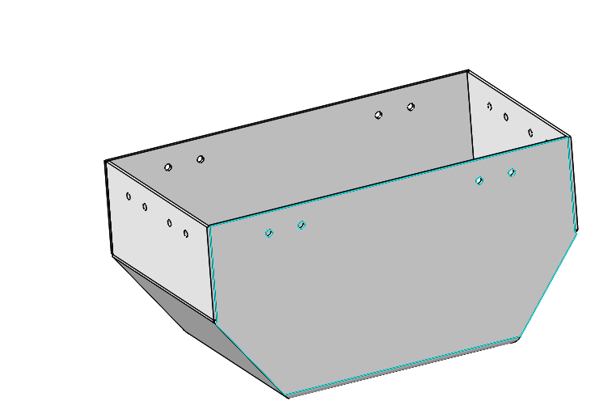

Medium size parts (such as Gimbal yaw shaft retainer plate):
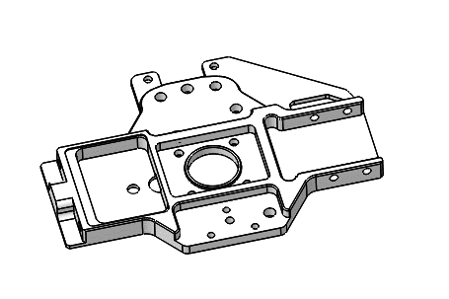
Small parts (the limit switch):
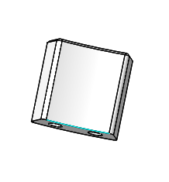

Signature:

Owner:
(seal)

Date:

Renter:
(seal)

Authorized Representative (signature):

Date:

