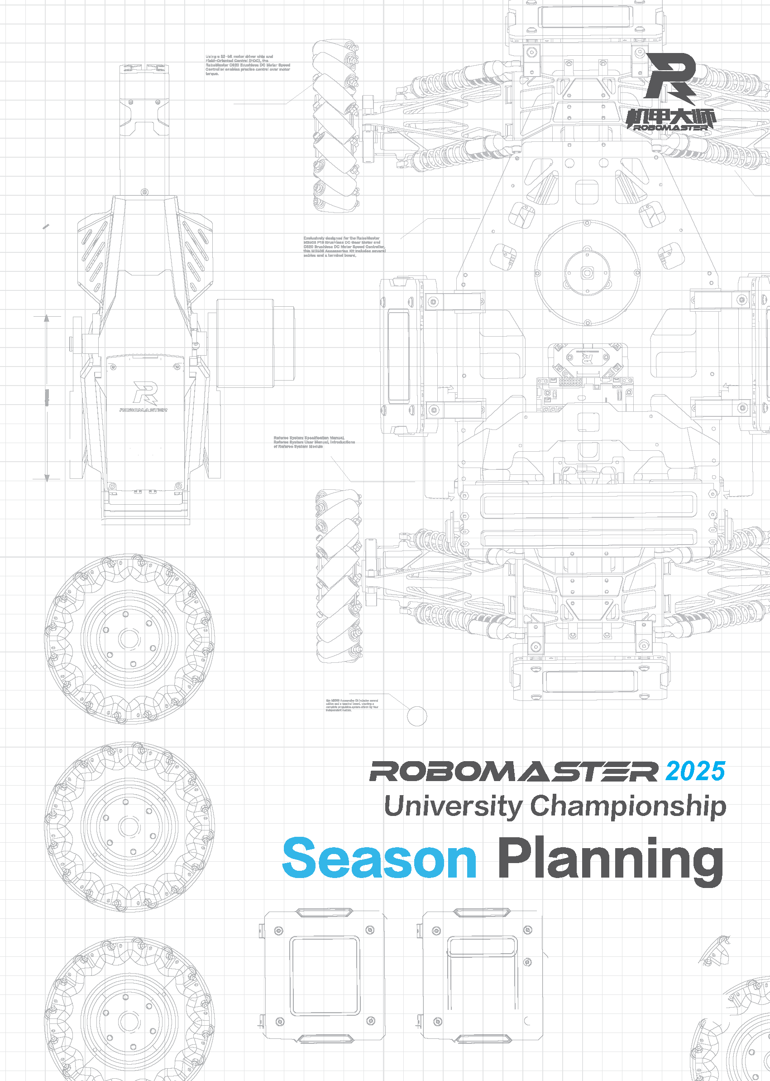

Prepared by (team name), (university name)

Released in (month) (year)

Table of Contents

Foreword 4

1. Team Goals 5

2. Retrospective & Analysis 6

2.1 Challenges and Problems in the Last Season 6

2.2 Root Cause Analysis 6

2.2.1 Analysis of “Planning-1” Problem (5 Whys Analysis) 6

Analysis of “Planning-2” Problem (Fishbone Diagram) 7

2.3 Problem Solutions 8

3. Project Analysis 9

3.1 Interpretation of Season 2025 Rules 9

3.2 R&D Project Plan 9

3.2.1 Infantry 9

3.2.2 Hero 9

3.2.3 Engineer 9

3.2.4 Sentry 9

3.2.5 Drone 9

3.2.6 Dart System 9

3.2.7 Radar 9

3.2.8 Human-Robot Interaction 9

3.3 Technical Reserve Plan 10

3.3.1 General Technical Reserve 10

3.3.2 Robot-specific Technical Reserve 10

4. Resource Availability Analysis 11

5. Team Management 13

5.1 Team Structure 13

5.2 Development of Rules and Regulations 16

5.2.1 Analysis of Focus on Rules and Regulations Development 17

5.2.2 Analysis of the Plan for Rules and Regulations Implementation 17

5.2.3 Closed-loop Analysis of Rules and Regulations Implementation 17

5.3 Culture Building 18

5.3.1 Team Culture Building 18

5.3.2 Competition Culture Infiltration 21

6. Publicity and Business Plans 23

6.1 Publicity Plan 23

6.2 Business Plan 24

# Foreword

This report was prepared by XXX (team name) for the RoboMaster 2025 University Championship. The key writers include:

|  |  |  |  |  |  |
| --- | --- | --- | --- | --- | --- |
| **Module** | **Writer 1** | **Writer 2** | **Writer 3** | **Writer 4** | **Writer 5** |
| **Mechanical** |  |  |  |  |  |
| **Hardware** |  |  |  |  |  |
| **Software** |  |  |  |  |  |
| **Algorithm** |  |  |  |  |  |
| **Management** |  |  |  |  |  |
| **Publicity** |  |  |  |  |  |
| **Business** |  |  |  |  |  |

# Team Goals

*(The following are the writing requirements. Please delete them after you complete your write-up.)*

*Clear Goals*

*Team goals should be challenging yet attainable, while aligning with the team's actual situation. Considerations for setting team goals encompass a range of factors, including but not limited to:*

*Available resources, such as funds, manpower, technical expertise, open source materials*

*Estimated fundamental and advanced tasks that can be completed in a season based on past experience*

*Current technical expertise and skill levels of other teams*

*Set the team goals for each area in this season through* *team discussions, including but not limited to:*

*The best results you wish to achieve or the minimum results you must achieve in the Regional Competition/Final Tournament.*

*Team-building goals (preferably quantifiable, such as establishing a talent development system that can manage X reserve members and a training system that can train Z new members under the guidance of Y senior members).*

*Technical breakthrough goals: technical milestones that the team has not yet achieved but aspires to achieve in this season. Please describe only one or two of the most challenging and valuable technical issues and provide the detailed plan in the Project Analysis section.*

*Basis for Goal Setting*

*Please summarize your process of thought and explain the rationale behind setting the aforementioned goals.*

*Actions for Progress Tracking*

*After the goals are set, it is essential to monitor the progress, identify the gaps, and make necessary reflections and continuous adjustments to achieve the goals. Please briefly describe your actions for progress tracking, for example, how you will implement the progress plan.*

# Retrospective & Analysis

*(The following are the writing requirements. Please delete them after you complete your write-up.)*

Review the previous season summary, analyze the reasons behind any gaps between the results and the goals in the previous season planning, delve deep into the root causes, and work out viable solutions accordingly. Please be careful what you write in this chapter, as it will be used for goal tracking and analysis in the subsequent project document.

## Challenges and Problems in the Last Season

Sum up the problems in last season using the following table:

|  |  |  |  |
| --- | --- | --- | --- |
| ***Code*** | ***Area*** | ***Title*** | ***Description*** |
| *Planning-1* *(Format: Stage-No.)* | *(Personnel, project,*  *funds, culture, etc.)* | *Briefly describe the problem* | *Describe the problem and its consequences* |
| *Planning-2* |  |  |  |
| *Planning-3* |  |  |  |

## Root Cause Analysis

Select an analysis technique and perform an in-depth analysis of the problems listed in 2.1 to identify the root causes.

***Root cause layer: the layer at which the team can, within its power, influence and drive systematic problem solving***

The root cause analysis techniques include, but are not limited to:

(1) 5 Whys analysis

(2) Fishbone diagram

(3) Fault tree analysis

### Analysis of “Planning-1” Problem (5 Whys Analysis)

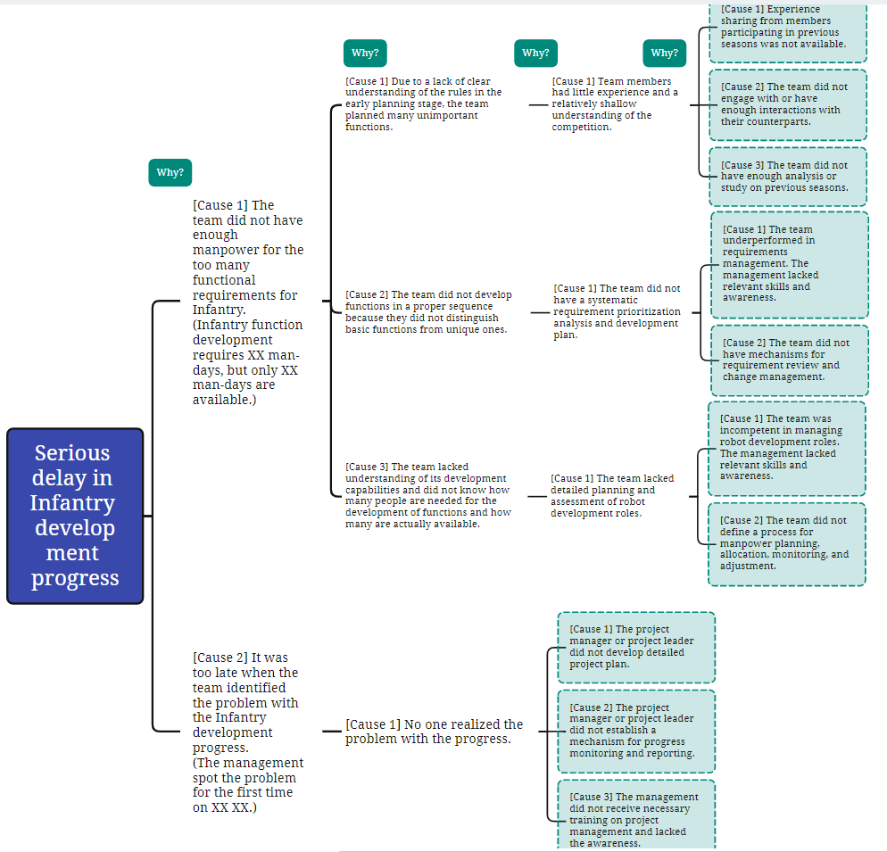

### Analysis of “Planning-2” Problem (Fishbone Diagram)

*Example:*

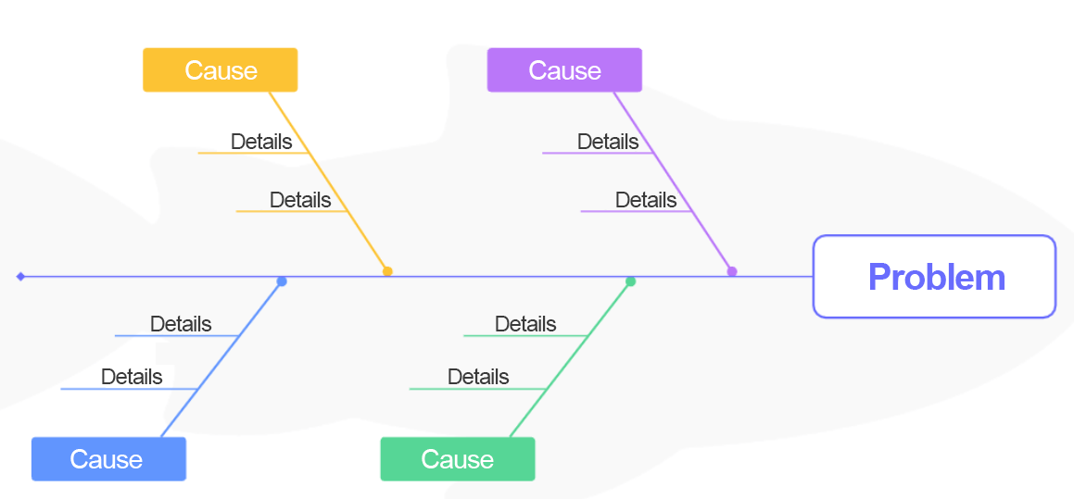

*“PMMME”:*

* *Personnel (P) include the problem-related* ***project group, technical group, and team members.*** *The personnel factor may involve the technical expertise, training scheme, cultural building, etc.*
* *Machinery (M) refers to the* ***equipment, tools, or techniques*** *used when the problem occurs. The equipment malfunctions, technical limitations, or improper use may contribute to the problem.*
* *Materials (M) include all* ***raw materials, resources, or products*** *used* *when the problem occurs. The quality issues of materials, supply chain problems, or wrong choices of materials may contribute to the problem.*
* *Methods (M) refer to the* ***operating procedures, workflows, or methodologies****. The problem may be caused by specific improper practices or operations, and possible process flaws and inadequate regulations.*
* *Environment (E) includes all external factors that may contribute to the problem, such as the* ***recognition and support from the university or college.***

##### 2.2.3 Root Cause Analysis Conclusion

|  |  |
| --- | --- |
| ***Code*** | ***Conclusion*** |
| *Planning-1* (Format: Stage-No.) |  |
| *Planning-2* |  |
| *Planning-3* |  |

## 2.3 Problem Solutions

|  |  |  |
| --- | --- | --- |
| ***Code*** | ***Solution*** | ***Indicator*** |
| *Planning-1* (Format: Stage-No.) | Specify detailed actions based on the ***root cause of the problem***, divide them into sub-tasks, and appoint owners for the sub-tasks. | Provide the quantifiable indicators that can be used for problem tracking and specify the indicators for each section of the Technical Assessment based on the schedule, for example: Mid-term Assessment: Indicator 1, Indicator 2 Final Robot Assessment: Indicator 1, Indicator 2 |
| *Planning-2* |  |  |
| *Planning-3* |  |  |

# Project Analysis

## Interpretation of Season 2025 Rules

*(The following are the writing requirements. Please delete them after you complete your write-up.)*

*Please provide your team's interpretation of the rules for this season.* ***Avoid*** *copying or quoting from official documents such as competition rules at length. Your own analysis is required.*

*Analysis and interpretation of the overall rules*

*Analysis of the modifications in the rules*

*Comprehensive understanding of the technical areas manifested by the rules*

## R&D Project Plan

### Infantry

*(The following are the writing requirements. Please delete them after you complete your write-up.)*

*The plan includes requirement analysis, design concept, R&D schedule, manpower planning, and analysis of technical challenges.*

* *Analyze the functional requirements for the robot type based on the rules*

*Describe the preliminary design concept*

### Hero

### Engineer

### Sentry

### Drone

### Dart System

### Radar

### Human-Robot Interaction

*(The following are the writing requirements. Please delete them after you complete your write-up.)*

*Human-Robot Interaction mainly refers to:*

* *Enriching the custom UI of the operator client through inter-robot communication*
* *Controlling robots through unconventional keyboard and mouse operations using custom controllers*

*If you have planned the use of relevant functions for this season, describe the details here.*

## Technical Reserve Plan

*(The following are the writing requirements. Please delete them after you complete your write-up.)*

*A technical reserve plan involves the technical knowledge and expertise for future seasons, such as automatic positioning and navigation algorithms, instead of those employed in the current season, such as gimbal control and automatic aiming.*

*Technical reserve involves the long-term accumulation of general technical knowledge and expertise that are not specific to a particular robot type or confined to a single season. The technical knowledge and expertise are classified into two types: those that the team currently lacks but aims to acquire in the future and those that the team already possesses but seeks to optimize from a medium to long-term perspective.*

### General Technical Reserve

*Applicable to all types of robots.*

### Robot-specific Technical Reserve

*Applicable to a specific type of robot.*

# Resource Availability Analysis

*(The following are the writing requirements. Please delete them after you complete your write-up.)*

1. *Review the resource usage in the previous season with a particular focus on examining the problems in resource usage and cost control. Outline the targeted measures for improvement in these respects for this season and evaluate their feasibility (a summary of these measures is required at the end of the season).*
2. *Overview of available resources for this season*

|  |  |  |  |
| --- | --- | --- | --- |
| ***Category*** | ***Source*** | ***Resource Description*** | ***Initial Plan for Resource Usage*** |
| *Funds* |  |  |  |
| *Materials* |  |  |  |
| *Processing Resources* |  |  |  |
| *Publicity Resources* |  |  |  |
| *XX Resources* |  |  |  |

1. *Overview of the budget (please present a detailed version in the “Budget Report” Excel file)*

|  |  |  |
| --- | --- | --- |
| ***Module*** | ***Available Funds*** | ***Remarks (If Any)*** |
| ***Infantry*** |  |  |
| ***Hero*** |  |  |
| ***Engineer*** |  |  |
| ***Sentry*** |  |  |
| ***Drone*** |  |  |
| ***Dart*** |  |  |
| ***Radar*** |  |  |
| ***Operations*** |  |  |
| ***Travel*** |  |  |
| ***Others*** |  |  |
| ***Total*** |  |  |

1. *Resource availability analysis*

*Analyze how available resources such as funds, technologies, personnel, and time can ensure the successful implementation of the R&D project plan. Evaluate whether existing resources are adequate to fulfill the plan, identify risks of resource insufficiency (if any), and devise tailored strategies to mitigate these risks.*

# Team Management

## Team Structure

*(The following are the writing requirements. Please delete them after you complete your write-up.)*

*Devise the overall structure of your team based on the actual situation.*

*Do not modify or delete the main elements of the table below. However, you may add, delete, or edit details such as XX structure, XX leader or group, and roles as needed.*

*You can delete the part of a robot type if your team does not have that type of robot.*

*You can also use your own descriptions relating to the software, hardware, embedded systems, algorithms, and computer vision.*

*You can delete the row of Vice Captain or Advisor if the role does not exist.*

*You can add groups such as tactical, logistics, etc. to the corresponding R&D or non-R&D parts based on your team’s structure.*

*If multiple persons assume the same management role, you can list all of them in the cell and split with line breaks.*

|  |  |  |  |  |
| --- | --- | --- | --- | --- |
| ***Management Structure*** | | | | |
| *Role Information* | | | *Management Information* | |
| *Title* | | *Responsibilities* | *Name* | *Year of Participation* |
| *Core Management* | *Captain* |  |  |  |
| *Vice Captain* |  |  |  |
| *Project Manager* |  |  |  |
| *Advisor* |  |  |  |
| *R&D Structure* | *Mechanical Leader* |  |  |  |
| *Software Leader* |  |  |  |
| *Hardware Leader* |  |  |  |
| *Algorithm Leader* |  |  |  |
| *Structure by Robot Type* | *Leader of Hero* |  |  |  |
| *Leader of Engineer* |  |  |  |
| *Leader of Infantry* |  |  |  |
| *Leader of Sentry* |  |  |  |
| *Leader of Drone* |  |  |  |
| *Leader of Darts* |  |  |  |
| *Leader of Radar* |  |  |  |
| *Operation Structure* | *Operation Manager* |  |  |  |
| *Logistics Leader* |  |  |  |
| *Publicity Leader* |  |  |  |
| *Sponsorship Leader* |  |  |  |
| *Financial Leader* |  |  |  |
| ***Team Member Structure* only involves the 35 regular members that are entered into the registration system, including the management.*** | | | | |
| *Group* | *Criteria for Regular Members in the Group*  *\*Regular members refer to the 35 regular members that are entered into the registration system.* | | *Target Number of Regular Members* | *Current Number of Regular Members* |
| *Mechanical* |  | |  |  |
| *xx* |  | |  |  |
| *xx* |  | |  |  |
| *xx* |  | |  |  |
| *Logistics* |  | |  |  |
| *Publicity* |  | |  |  |
| *Sponsorship* |  | |  |  |
| *Finance* |  | |  |  |

*Responsibilities: In this column, please specify the functions, duties, and requirements for the role in various stages and scenarios. For example:*

*R&D planning stage, team recruitment stage, preparation stage (R&D, testing, iteration), and on-site competition stage*

*For roles relating to the operation structure, please incorporate different project goals into the description of responsibilities, including but not limited to team building, cultural building, recruitment program, publicity, sponsorship, and financial goals.*

*Year of Participation: The current 2025 season does not count. For example, if the 2024 season marked the person’s first year participating in the RMUC, the Year of Participation is “1”; if the 2025 season marked the person’s first-time participation, the Year of Participation is “0”.*

*Regular Member: *Regular members in this table refer to the 35 regular members that are finally entered into the registration system.*

*Criteria for Regular Members in the Group: These are criteria for selecting regular members in the group. Based on the team’s actual assessment and selection, the criteria may include, but are not limited to hard skills such as R&D and publicity, soft skills such as collaboration, attendance, and attitude.*

*Target Number of Regular Members: Please specify based on the team’s target for regular members in the group.*

*Current Number of Regular Members: Please specify based on team’s actual situation.*

*Key Takeaways:*

* *Typically, a Technical Leader is required for each technical area. Technical Leaders are expected to possess strong coordination, professional, and technical skills. They should exhibit superior technical expertise in their respective areas and provide ample opportunities for the personal development of their members.*
* *In general, a team requires test personnel (not included in the table but can be added as required). However, test personnel are not a separate role solely dedicated to testing. Members in various technical areas are tasked with testing, including module testing, robot function testing, and testing of robots in a battle during the Preparation Period. Test personnel shall have the right to determine whether a development task has been completed. They will eventually compete to be selected as the Operator in the competition.*
* *In general, a team can be divided into different project groups by robot type. Each project group can be assigned a Product Manager (robot-specific leader), who should preferably be an experienced team member that is knowledgeable and familiar with various technical areas, perceptive about robotic requirements, and is able to determine the level of task priority. The Captain discusses with Product Managers on the positioning and functions of each robot type and translates them into respective project requirements. Each Product Manager will then discuss with their own project group members and confirm project requirements. Additionally, Product Managers also need to determine the required manpower with Technical Leaders. Ultimately, the team will formulate a project plan based on the requirements and implement it, the progress of which shall be monitored by Project Managers.*
* *Reference: https://zhuanlan.zhihu.com/p/33474355*

## Development of Rules and Regulations

*The rules and regulations of a team refer to a series of rules and regulations developed by and for the team in order to guide team members’ behaviors, workflows, and collaboration. The aim is to ensure efficient team operations, improve productivity, maintain orderly functioning of the team, and promote collaboration among team members. The rules and regulations include but are not limited to:*

1. *Members’ code of conduct, such as attendance and requirements* *of* *conduct for lab personnel*
2. *Work procedures, such as those for requirements management, progress management, timesheet management, and relevant requirements*
3. *Team collaboration rules, such as communication mechanisms (regular meetings, reports, feedback, etc.) and collaboration methods and norms*
4. *Team development system, such as training for new team members*

*List the focus of your team’s rules and regulations based on the Retrospective & Analysis**part* *in**Chapter 2 and the changes in the new season.*

*For example, you may start by answering the following questions:*

1. *How do you ensure that problems listed in the Retrospective & Analysis**part never happen again?*
2. *How do you improve the training for new team members to build a stronger team?*
3. *How do you improve the efficiency of collaboration between different groups of your team in the 2025 season?*
4. *How do you reduce project costs in the 2025 season?*

***Note: In this chapter, provide only the updated rules and regulations of your team for the 2025 season, rather than list all applicable ones.***

### Analysis of Focus on Rules and Regulations Development

|  |  |
| --- | --- |
| ***Overview of Rules and Regulations Development*** | ***Analysis*** |
| *Summarize updated rules and regulations of your team for the 2025 season, point by point.* | *Describe why the rules or regulations are important. You may provide an in-depth analysis of the team’s existing problems, the environmental changes the team faces, the feasibility of the rules or regulations, and expected results.* |
|  |  |
|  |  |

### Analysis of the Plan for Rules and Regulations Implementation

*Based on 6.2.1, provide a detailed description of the plan for the development of key rules and regulations for the 2025 season.*

**5.2.2.1** **Detailed Description of the Plan for XX Rules and Regulations**

### Closed-loop Analysis of Rules and Regulations Implementation

|  |  |
| --- | --- |
| ***Overview of Rules and Regulations Development*** | ***Indicator*** |
| *The same as what has been described in section 3.1* | *Use indicators to measure the effectiveness of rules and regulations, illustrate the value of the updated parts, and develop closed-loop metrics for each section of the Technical Assessment based on the schedule.*  *Mid-Term Progress Assessment:*  *Final Robot Assessment*  *Post-Regional Competition* |
|  |  |

## 5.3 Culture Building

### 5.3.1 Team Culture Building

*(The following are the writing requirements. Please delete them after you complete your write-up.)*

*Please fill in the table below to explain how you will build team culture in the four aspects.*

*Please indicate the role of the writer and complete the following sections as required.*

*Recommended role:*

*Captain for the 2025 season*: XX

*Project manager for the 2025 season*: XXX

*Operation manager for the 2025 season: XXX*

|  |  |  |  |  |  |
| --- | --- | --- | --- | --- | --- |
| *Category* | *Content (Sample)* | *Purpose and Objective* | *Details (Sample)* | *Time* | *Remarks* |
| *Cultural rituals* | 1. *Onboarding activities for new members* 2. *Awarding ceremony for veteran members* | *Promote the core culture of the team (questionnaires show that XX% of team members feel the team culture through the ceremonies/activities) and create a sense of belonging for new members (XX% of members feel cared for).* | *1. Every December, we hold a ceremony for veteran members who have completed training and passed the assessment. At the ceremony, the members will receive their appointment letters and team uniforms. On the uniforms, the team slogan, logo, and the respective member's name are printed. For the plan for this year, please visit the link. For historical data, please check the Remarks column.* | *August 1, 2024: Start material design.*  *August 15, 2024: Complete review within the group.*  *August 20, 2024: Complete review within the team and contact suppliers.*  *······* | *Uniform image.jpg*  *Design concept.docx* | |
| *Cultural symbols* | 1. *Team slogan* 2. *Cultural IP* 3. *Featured camp* 4. *Dedicated management mechanism* 5. *Cultural wall* | *Spread the competition culture externally (conduct sample surveys to check the cultural perception within other teams) and foster greater cohesion within the team (team member retention rate at the end of the season).* | 1. *Every year, from December to February, our college holds a winter holiday camp where mechanical engineering students design and build small engineering vehicles......* 2. *Every September, we review and discuss the effectiveness and future development of our management mechanism.* | *November 1, 2024*  *Plan the timeline for the holiday camp.*  *November 8, 2024*  *Specify tasks for each group to complete during the camp.*  *December 2024*  *Release a poster.*  *······* | *Task package of each group*  *Reference text and pictures from historical holiday camps*  *Team management logs* | |
| *Cultural figures* | 1. *Text and pictures about the figures* 2. *RMer-XX Team* | *1. Establish exemplary figures for team members to learn from (conduct surveys to check team members' recognition of outstanding individuals).*  *2. Define team member profiles and create a concrete representation of shared values (conduct surveys to check team members' recognition of the team).* | *Release featured articles with graphics for monthly outstanding individuals in the middle of each month.* | *The 1st of each month*  *Initiate a vote within the team.*  *The 7th of each month*  *Count the votes.*  *The 10th of each month*  *Conduct interviews.* | *List of outstanding representatives of the team*  *Team member profiles*  *(Clarify the technical skills and values that are required for team members, characteristics of people that are not suitable for the team, and how to find the right people for the team.)* | | |
| *Cultural stories* | 1. *Themed cultural videos* 2. *Team history sharing* | *Permeate team culture throughout the team and align team members on shared values.* | *Publish quarterly updates on team culture, including cultural stories and representative cultural output.* | *Keep collecting materials throughout the entire process from preparation to competition.*  *September 30, 2024*  *Define the team's core culture for this season.*  *October 15, 2024*  *Plan the script.*  *······* | *Content of cultural stories* | | |

*Note: Reference for team member profiles*

People with the following characteristics are ideal candidates:

1. Possess a strong sense of purpose and a belief in their ability to get things done.
2. Be proactive in expanding their knowledge and skills.
3. Be passionate about and show initiative in robot competitions.
4. Communicate honestly and openly.
5. Be skilled at uncovering truths, identifying problems, and finding solutions.
6. Be able and willing to empower and support their teammates.

People with the following *characteristics will be reconsidered during selection:*

1. Be primarily motivated by academic advancement.
2. Tend to compromise or give up when faced with challenges.
3. Fail to finish the training or understand the purpose of training.
4. Approach problem-solving through random trial and error without thoughtful consideration.
5. Make impulsive decisions but do not take responsibility for the outcomes.
6. Demonstrate a lack of respect for the team or engage in behavior that disrupts team harmony.

*Thoroughly discuss the above points with veteran team members or advisors to help your team systematically plan culture building, quantify your input workload and expected outcomes, and improve the efficiency in the entire process from preparation and competition.*

### 5.3.2 Competition Culture Infiltration

*(The following are the writing requirements. Please delete them after you complete your write-up.)*

*Recommended role:*

*Captain for the 2025 season*: XX

*Project manager for the 2025 season*: XXX

* *Why are there team members participating in the competition again? What characteristics do they have? (These can be analyzed by communicating with the veteran members that stay in the team.)*
* *Are there veteran members willing to come back to help the team? In what form do they come back? Why do they come back? (These can be analyzed by communicating with the veteran members and advisors.)*
* *What kind of new members are easy to stay? What kind of new members are easy to lose? (These can be analyzed based on recruitment results or new member performance.)*
* *What content does the organizing committee disseminate that can effectively help the management with team building? (These can be analyzed by communicating with the current members and veteran members.)*

Team management is invited to deliberate decisions and analysis around the foregoing questions and to think about the significance of culture building and infiltration. Other insights and suggestions can be added based on the team's actual situation, such as solving what practical problems of the team, playing what roles, and gaining what experience in cultural inheritance of the team. It is expected to help the team build awareness and do a good job of cultural inheritance by thinking about these questions.

# Publicity and Business Plans

## Publicity Plan

*\* Quarterly publicity assessment is canceled in RMUC 2025. Outstanding PR Team of the year will still be selected at the end of the season. The selection method is changed to annual project-based assessment.*

*\* The core projects in the assessment are listed below. The operation or PR team leader is responsible for project planning. The following projects are for reference only. The actual publicity projects can be planned based on the team's actual situation.*

*\* There is some directional overlap between the publicity plan and the cultural building plan. The cultural building plan focuses on "team building mechanism or system", whereas the publicity plan focuses on "publicity content output". The leaders of the operation team and PR team are responsible for appropriate division of labor and cooperation on the two plans.*

1. *Core projects in the annual publicity assessment:*
2. *Recruitment: A "Recruitment Review" with an empirical summary is required, including but not limited to data recording, identification and iteration of recruitment profiles, actions with the best publicity effect, and the main reason why the new members choose to join the team*.
3. *RMer series:*
   1. *Project introduction: In line with the officially released RMer series, this project aims to promote the recognized outstanding members in the team as role models for other members to understand, recognize, and learn from, and to attract more like-minded new members.*
   2. *Project content: Record the preparation and participation process of the recognized outstanding members in the team, including the working process, key problem-solving process, and collaborative discussion process, accompanied by timely interviews to understand their problem-solving ideas and actual thoughts.*
   3. *Project output format: Posts and videos with the subject matter highlighted are both acceptable.*
4. *Event review:*
   1. *Project introduction: Make stage-by-stage recordings and publicity packages for different events to show the real atmosphere of the battlefield and the preparation status of the team.*
   2. *Project output format: Posts and videos are both acceptable.*
5. *Merchandise plan: Fill in based on the team's actual situation. The team uniform can be described though it is not reviewed here.*
6. *Full-season publicity review plan:*
7. *Internal: Find out the team members' satisfaction with and feedback and suggestions on the work of the publicity team in forms such as surveys and questionnaires.*
8. *External: Analyze the publicity effect based on data on the publicity content, such as post views and video views.*
9. *Additional project of the team:*

## Business Plan

*(The following are the writing requirements. Please delete them after you complete your write-up.)*

*Please include the following key points in the team's business plan:*

1. *Sponsors Plan*

*The sponsors plan can encompass the following elements: categorizing sponsors by industry, defining target numbers and scales, specifying cooperation models (including sponsor classification), and identifying channels (such as alumni associations) for sourcing sponsors.*

1. *Resource Advantages and Highlights for Sponsorship*

*Identifying and listing the resources that the team can offer to potential sponsors will help facilitate collaborations with sponsors. The team's resource advantages include a robust network of self-media accounts, strong creative content production capabilities, expertise in developing team uniforms and innovative merchandise, and a notable ability to enhance brand visibility for the sponsors within the campus.*

1. *Sponsorship Goals*

*Based on the team's existing financial gaps and the sponsorship benefits specified in the Sponsors Manual, determine the sponsorship goals for this season and establish a sponsorship benefits framework tailored to sponsors at various levels.*

*Note: Please refer to the team's sponsoring materials, including Sponsors Manual, sponsorship guides, FAQs, evaluation methods, and Promotional PPT and leaflet templates. If you have any questions, let us know in the sponsorship group.*

