RoboMaster 2019 High School Robot Theme Summer Camp Resume
Name |  | Gender |  | (Photo)
English grade |  | Grade | Last mock test score
School |  | Research track | Mechanical / Embedded System / Algorithm
Current grade level |  | Contact information
Province |  | E-mail address
Project experience
(All participated projects, such as robot competitions, patents, independent design, etc.)
Date | Project name | Description
Awards
Date | Award | Description
Programming language, software, and industrial skills
(The following topics aim to help you better understand the basics of the summer camp and gain relevant knowledge in advance. This will allow you to learn and work more efficiently during the summer camp to find your track of interest, and choose an appropriate topic to study. Open-ended questions do not have right or wrong answers. Students who wish to go the extra miles can actively think and answer them. Focus on presenting your thought process rather than just giving a final answer. Please answer questions from at least one technical track.)
I. Required Questions for Mechanical Track
- Build the following model (no specific requirements if no specifications are given):
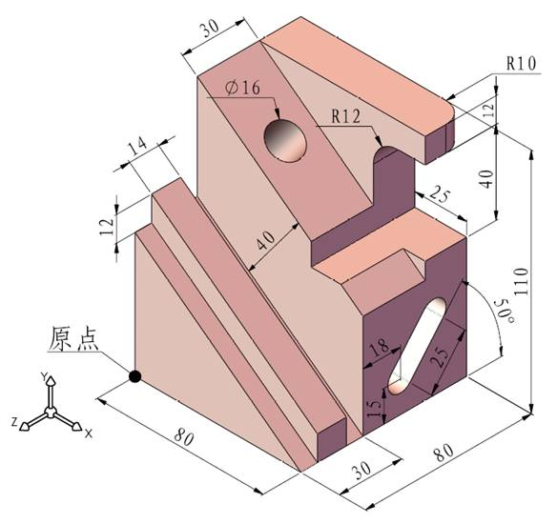
Origin
- There is a game robot that needs to complete two sets of actions, namely clamping and loosening as well as lifting and lowering (both straight up or rotating up are acceptable) the prop ball. According to the rules, it is required to use up to two driving link (motor or cylinder) to perform these two sets of actions. There will be extra bonus if two sets of actions are done with only one driving link. The speed, power and size of the motor or cylinder as well as the quality of the prop ball can be ignored, the diameter of the prop ball is 50mm, and it is assumed that the ball will not be deformed (PS: suction cups, tapes, hook-and-loop fasteners are not allowed to be used as clamps). Please answer the following questions:
  - Please describe in words the several structural solutions that can achieve this function, and analyze their advantages and disadvantages.
  - Please choose an optimal solution and develop 3D drawings.
  - From your own structural design, please introduce the materials (including but not limited to metal, plastic, etc.) used and the corresponding processing methods, tools, etc.
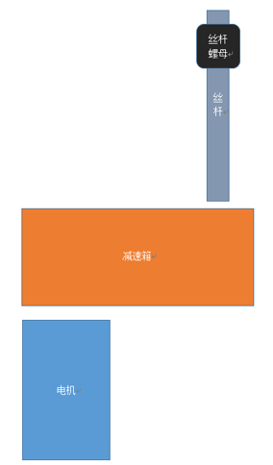
- There is a lifting robot that needs to be equipped with a lifting device to raise cargos. The solution is determined as follows. A motor is used to connect the input end of a gear reducer. The output end of the gear reducer is connected with the screw rod; the rotation of the screw rod causes the feed screw nut to move up and down to lift the cargo. It has been determined that a gearbox with a reduction ratio of 20:1 is used; the transmission efficiency is 0.7 and the rotating efficiency of the screw rod id 0.8. The parameters of the optional motors are as follows:
Reduction gearbox
Screw rod
Feed screw nut
110W，3000r/min
130W，3000r/min
150w，5000r/min
Motor
200W，6000r/min
The robot needs to lift a 100kg object at a speed of 0.1m/s. Select the appropriate motor according to the above conditions and confirm the screw lead. Please write down the calculation process. (The definition of transmission efficiency, screw lead, etc. can be found in Mechanical Design, Mechanical Principles, Mechanical Design Manual, etc.)
II. Required Questions for Embedded System Track
- Please explain the following nouns and state their perspective roles in single-chip microcomputers (SCM):
DMA:
NVIC:
FPU:
SRAM:
GPIO:
JTAG:
Watchdog:
- There are two main modules in RoboMaster robot control system, which are motion control module and perception decision module. The perception decision module is responsible for collecting sensor data and making motion decisions, while the motion control module is responsible for receiving control commands and actually controlling the motor of robots. For ease of maintenance and upgrades, these two main modules are controlled using two separate hardware. For this system, please answer the following questions:
  - Since the two modules are hardware on the same robot but independent of each other, a communication mean is needed to transfer data between the two modules. Please select one of the following communication methods that you think is most suitable, and explain why.
Ethernet, WIFI, Bluetooth, USB, CAN, serial, I2C, SPI.
  - Please design a communication protocol that enables the motion control module to be operated by the perception decision module based on the characteristics of this system. The perception decision module should at least be able to control the moving speed and direction of the chassis. Additional functions can be expanded. Please write down the composition of the communication protocol packet in code or words.
  - If you add another hardware module to this system and you want these three modules to be able to communicate with each other using only the one signal line, please reconsider and answer question 1) and 2) based on this requirement.
- What do the following declared variables mean in C language?
  - static const int a = 10; What do "static" and "const" have in common? What's the difference? Where are the storage locations of these two variables in a SCM?
  - const int *ptr; Please describe the data type of the variable "ptr" in words.
  - int* const ptr; Please describe the data type of the variable "ptr" in words.
  - int (*ptr)[10]; Please describe the data type of the variable "ptr" in words.
  - int *ptr[10]; Please describe the data type of the variable "ptr" in words.
- The following code is a fifo read function. If there are two tasks obtaining data in the same fifo of a SCM system and these two tasks have different priority orders, the high-priority task will interrupt the execution of the low-priority one. Is the implementation of this code reasonable in such a scenario? If not, how should you modify it? (Please review the knowledge on thread safety before answering the question.)
void* fifo_s_get(fifo_s_t* p_fifo)
{
void* retval = 0;
if (0 == p_fifo->used_num)
return 0;
if (0 == p_fifo->used_num)
{
return 0;
}
if(p_fifo->p_read_addr > p_fifo->p_end_addr)
p_fifo->p_read_addr = p_fifo->p_start_addr;
retval = *p_fifo->p_read_addr;
p_fifo->p_read_addr++;
p_fifo->free_num++;
p_fifo->used_num--;
return (retval);
}
- Since the processor can run in a big-endian mode and a little-endian mode, special processing is required when communication occurs between processors with different endian modes. Please write down the data processing method when a float type variable is transmitted by a processor with a little-endian mode to a processor with a big-endian mode.
- The self-balancing scooter in the image below is a new type of transporter, which is very popular recently. Due to its small size and weight, it can be easily carried on subways and buses, solving the "last mile problem". Please analyze the principle of a self-balancing scooter from a technical point of view based on what you know. List out the sensors needed for a self-balancing scooter, and specify how to use a controller to control a self-balancing scooter (draw a data flow diagram or a control system block diagram).
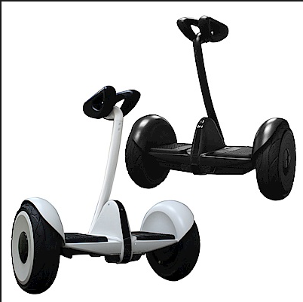
- The gyro sensor used in the ROBOMASTER International Development Board is MPU6500. It is known that the sensor can acquire the accelerations ax, ay, az in three directions of the right hand xyz and the angular velocities gx, gy, gz around xyz at a frequency of 500 hz. Please use the data from the sensor to calculate the angle when the international development board is rotated from the z-axis (where the gravitational acceleration is going down along the z-axis) and rotated around the x-axis. Draw a diagram and explain the calculation principle.
III. Required Questions for Algorithm Track:
- The robot chassis consists of four X-shaped Mecanum wheels with a track and wheelbase of 1 m. The forward direction of the chassis is the positive direction of the x-axis, the left is the positive direction of the y-axis, and the upward direction is the positive direction of the z-axis. The chassis establishes the odometer coordinate system with the current pose as the odometer origin. The body coordinate system is located at the center of the robot chassis. The robot chassis moves forward for 1s at a speed of 2 m/s in the body coordinate system, and then rotates counterclockwise for 2s at an angular velocity of π/6 rad/s before shifting to the right for 3s at a speed of 1m/s.
Now please describe the transformation relationship between the body coordinate system and the odometer coordinate system in mathematical language,
and calculate how many degrees the four Mecanum wheels have rotated respectively.
(Write the code or write down the calculation process by deriving the formula.)
- Set the robot to navigate in a two-dimensional space (xy), and the resolution of the map is 1, i.e. each grid is 1*1. The unit speed is$1$, and the control loss brought about by the single control is $u^{2}=u_{x}^{2}+u_{y}^{2}$. For example, the single control period of the robot is$t=1$, and the position of the robot is $x\left(t\right)=x_{0}+u_{x}*t$,$y\left(t\right)=y_{0}+u_{y}*t$, and $x_{0},y_{0}$ is the position of the robot at the last moment. The speed that the robot can use at the current position is -1, 0, 1.
The robot needs to go from point A to point B. Please use A* algorithm to search out the control sequence to ensure that $E+T$ (E is the sum of the control losses from A to B, and T is the total time used from A to B.) is the minimum number.
(Write down your train of thought and the calculation process.)
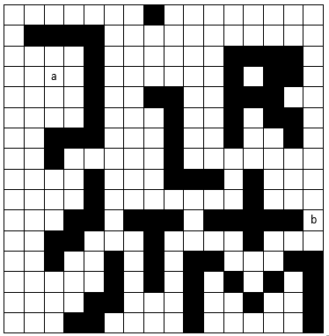

- Which sensors have you used? What physical quantities are measured by these sensors? What is the raw data? Is the sensor data noisy? Where does the noise come from? How do you effectively use the sensor data and avoid noise hazards?

