RoboMaster 2019 High School Robot
Theme Winter Camp Resume
Name |  | Gender |  | (Photo)
English grade |  | Grade | Last mock test score / 2017 college entrance examination provincial line one
School |  | Research track | Mechanical / Embedded System / Algorithm
Current grade level |  | Contact information
Province |  | E-mail address
Project experience
(All participated projects, such as robot competitions, patents, independent design, etc.)
Date | Project name | Description
Awards
Date | Award | Description
Programming language, software, and industrial skills
1. Open-ended Questions - Optional
(The following topics aim to help you better understand the basics of the winter camp and gain relevant knowledge in advance. This will allow you to learn and work more efficiently during the winter camp, find your track of interest, and choose the appropriate topic to study. Open-ended questions do not have right or wrong answers. Students who wish to have a better understanding of the camp can actively think and answer them. Focus on presenting your thought process rather than just giving a final answer. These questions are optional.)
1. What is the output after running the code in Image 1?
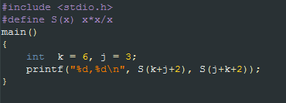
Image 1
2. Please explain how you would use two stacks to implement a queue.
3. Please explain the function achieved by the code in Image 2 below. How would you write the code without using recursion? What do you need to pay attention to when using recursion (such as efficiency, memory usage, and constraints)?
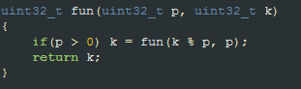
Image 2
4. What do you think will be the result of the code output in Image 3 below? Describe the structure of st in the memory.
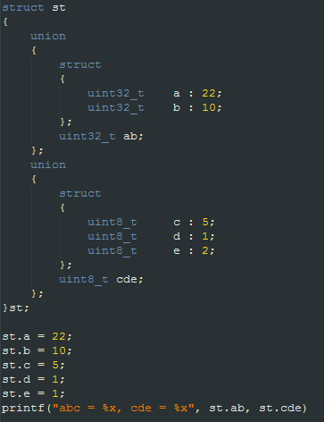
Image 3
5. There is a string (a) containing only uppercase and lowercase characters. Please write a program that outputs the first letter in a that only appears once, or else returns 0.
6. As shown in Image 4, on top of a movable trolley stands a pole that is unstable and that could fall down at any time. The wheels of the trolley are controlled by electric motors, and you can control the rotational moment M of the trolley motor. At the same time, you can also get the number of turns of the wheels N (which can be accurate to the decimal) and the incline angle α of the pole relative to the vertical position. (1) Please design a system to control the movement of the car to ensure that the pole will not fall. The system control cycle is about 2~50 ms. Please also provide a brief description. (2) Can the system you designed prevent the pole from falling while also moving the trolley to the designated location? If so, please provide a brief explanation.
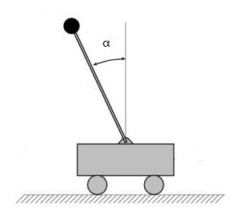
Image 4
7. RoboMaster's speed monitoring module mainly uses two infrared photoelectric switches as sensors. A sketch is shown in Image 5. When the photoelectric switch is blocked, it outputs a low level signal. (1) Please choose a single-chip microcomputer you are familiar with. From the single-chip microcomputer peripheral to the software logic, explain how you can use the mechanism in Image 5 to count and monitor the speed of the projectiles. (2) If the speed of launch is too fast, there are more than two bullets in the barrel of the speed monitoring area. What method would you use to solve and handle this issue? (Assume the barrel can be very long)
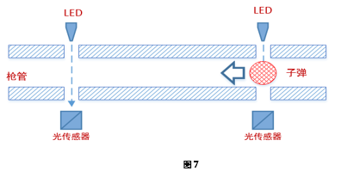
Barrel
Light sensor
Projectile
Light sensor
Image 5
8. As shown in the figure, the parallel four-bar linkage mechanism has a load of 100N and the mechanism is stable at its current position. Please calculate the magnitude and direction of the torque represented by the red and green arrows. (Note: the magnitude of the torque represented by red and green is relative to ground).
(Mechanism force analysis and calculation unit: N, mm)
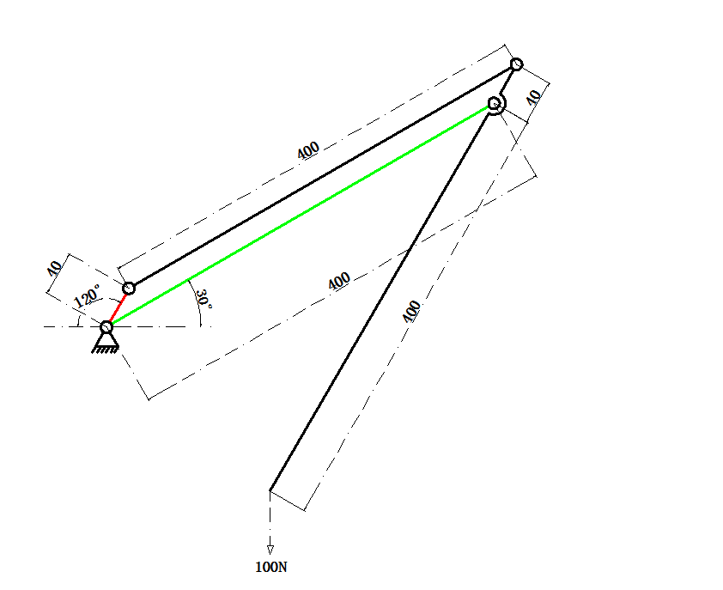
Image 6
9. In the SOLIDWORKS sketch, there is a square with a circle inside. Please explain how to mark dimensions so that the square and circle are fully defined.
(SolidWorks sketch section)
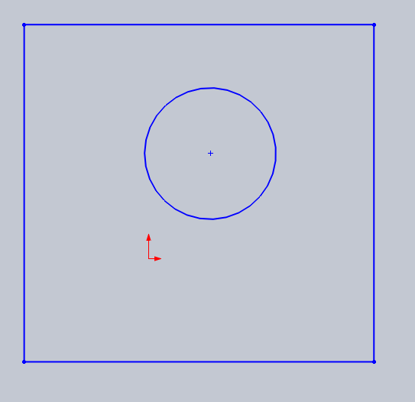
Image 7
10. Given the model below, write the modeling steps and note the modeling operations (commands) used.
(SolidWorks modeling operations section)
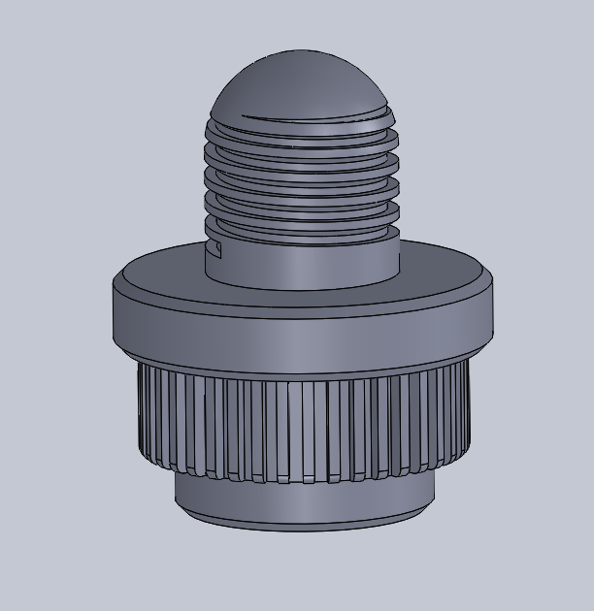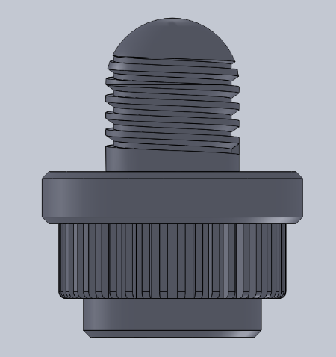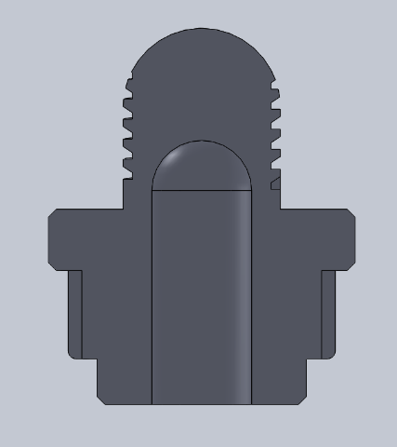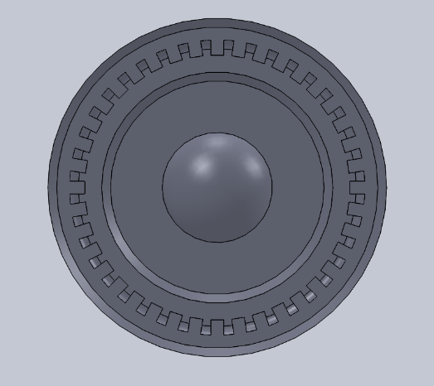
Image 8
11. If you have participated in some robot competitions, list the characteristics of the materials (specific to the model, including but not limited to metal, plastic, etc.) you used, the methods and tools used to manufacture the parts, and so on.
For example: I have used carbon fiber sheets, which are processed with an engraving machine and can be used to design various flat shapes. Carbon fiber is characterized by high strength and low density compared to aluminum alloy plates, so it can effectively reduce the mass of the structure.
12. There are two AI robots (numbered 1 and 2) in the red starting zone.
1) You must avoid the yellow obstacle blocks, cross the grid map to carry the blue points boxes and return them to the starting zone.
2) The 7 blue squares each represent a different amount of points.
3) The robot can only move up, down, left, and right and cannot cross the blue boxes. The map looks like this:
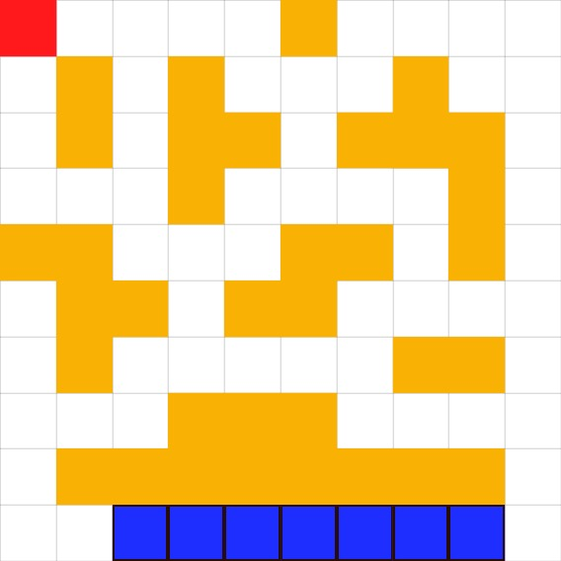
Image 9
The game is turn-based. In the first round, robot 1 starts from the starting zone, gets a blue box from either end of the array of blue boxes and returns it to the starting zone. The score obtained in a single round is calculated as follows:
Single score = the score represented by the blue square - the number of grids crossed in a round trip (including the starting zone grid). In the second round, robot 2 starts from the starting zone and gets a remaining blue box from either end of the array of blue boxes and carries it back to the starting zone. In the next round, it is robot 1's turn, and so on. The two robots take turns moving until all the blue boxes have been moved and the game is over. After all the single scores are added, the robot with the highest score wins.
(1) Write a program that calculates the shortest path from the starting zone to the leftmost and rightmost blue boxes, and write your algorithm and problem solving ideas below.
(2) Given an arbitrary array of 7 blue boxes, predict whether robot 1 will win. For example: Given a blue box array [1000,1,1,1,1,1,1], if robot 1 picks up the blue box worth 1000 points in the first round, it will definitely win.
Note:
1. The robot can choose to carry a box from either one of the two ends of the array of blocks, but cannot carry the inner blocks.
2. Assume that each AI robot wants to maximize its score.
3. If the robots end up getting the same score, then robot 1 is the winner.
4. The points assigned to the blue boxes in the array must be non-negative and must not exceed 10,000.
Please write the program and algorithm, as well as your problem solving ideas below.

